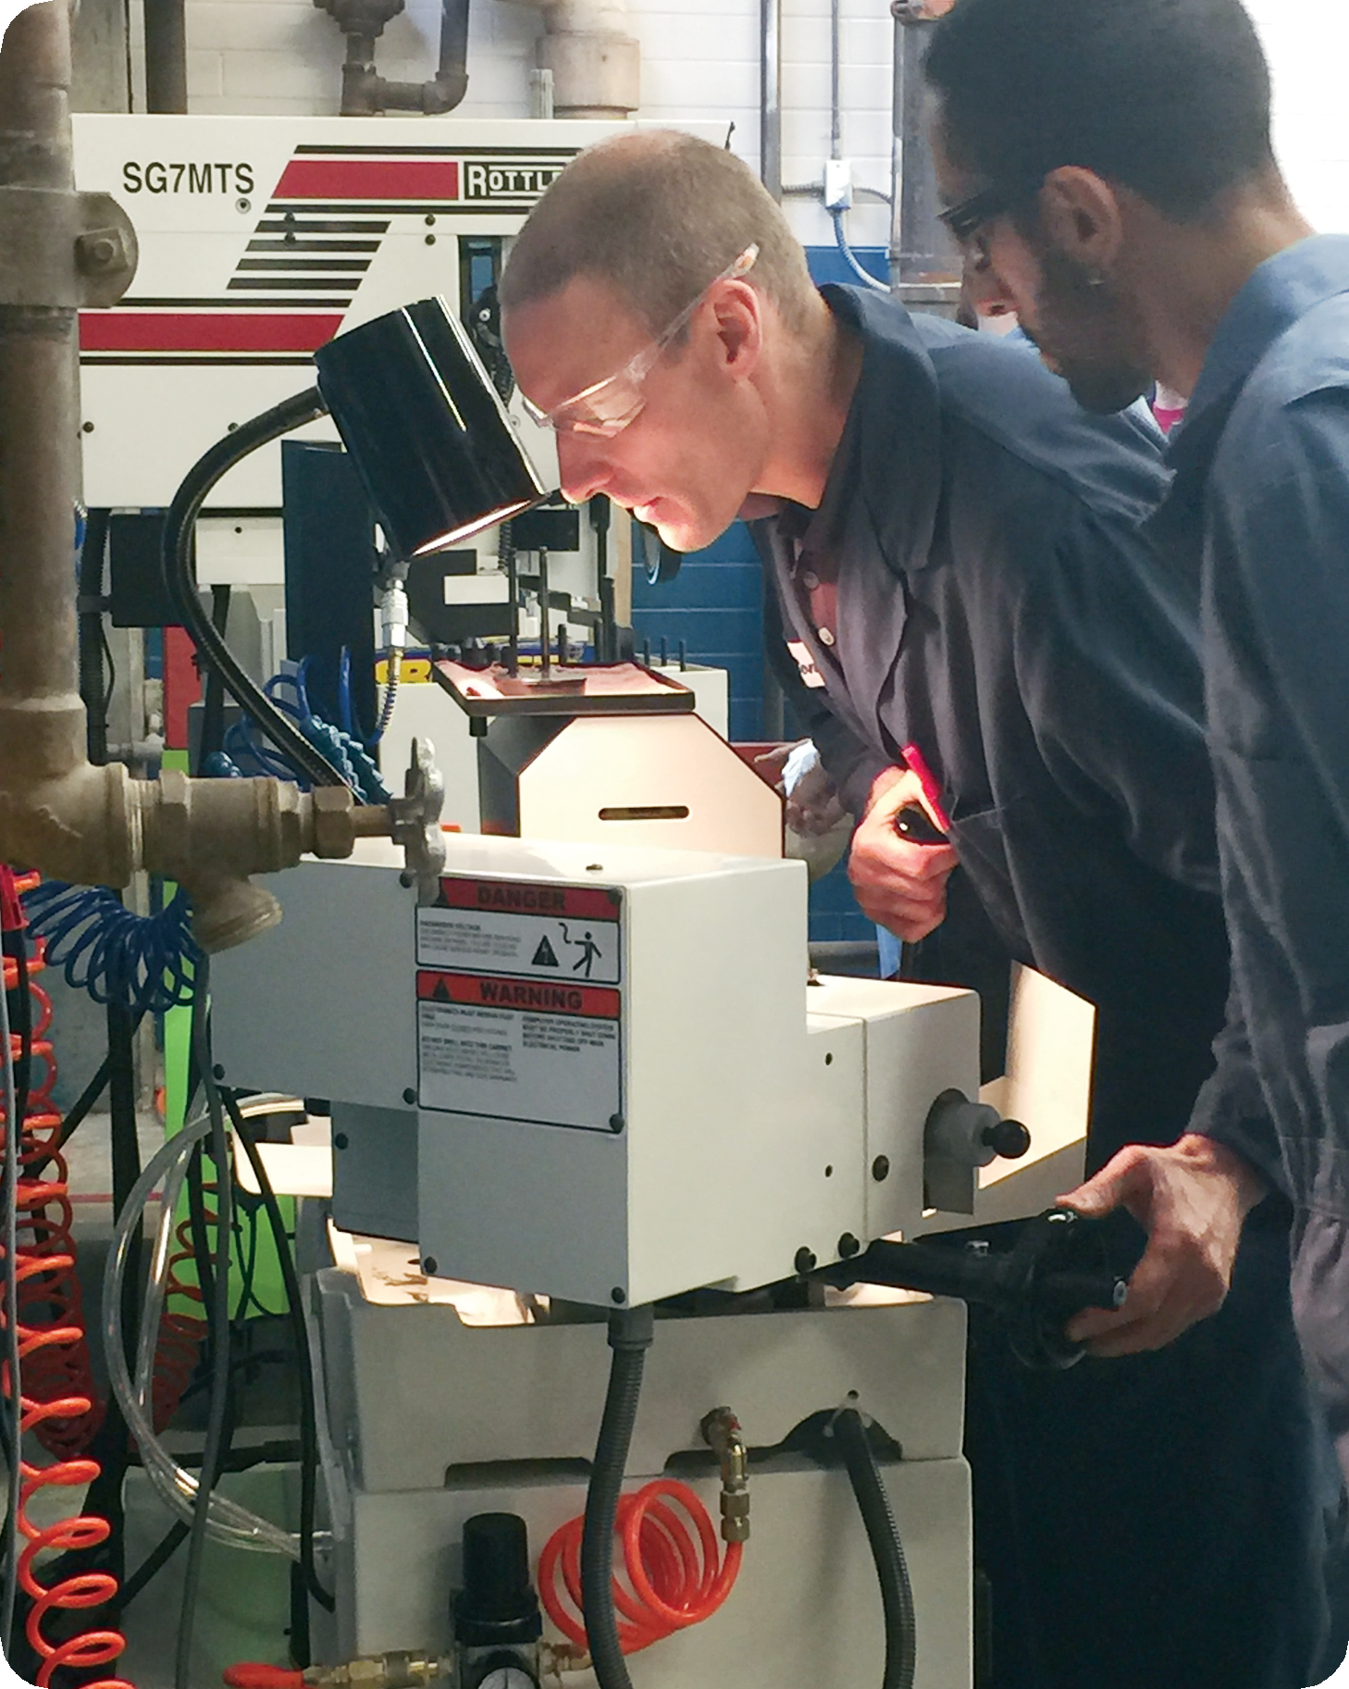

2017-2019 Operational Plan

Updated 06/2017

2017-19 OPERATIONAL PLAN ACCESS
Investigate, purchase, and implement schedule development software.
Offer selected degrees and certificates in a fully online format, and develop appropriate marketing plans.
Develop and implement Job Corps partnerships to offer Basic Education for Adults, College Success Skills, High School 21+, Allied Health, and Computer Information Systems courses.
- Increase instructional and administrative capacity for Basic Education for Adults across the District:
Investigate hiring full-time Basic Education for Adults Faculty for Whidbey Island Campus;
Investigate hiring Basic Education for Adults Instructional Technician/Navigator for Whidbey Island Campus;
Hire Navigator to serve Basic Education for Adults and Open Doors.
Increase High School 21+ course offerings.
Provide access to High School 21+ and Life Transitions students in San Juan County.
Expand Open Doors partnerships to include Burlington-Edison, La Conner, Anacortes, and Concrete school districts.
Expand INVEST to second cohort and hire Special Education instructor to support INVEST and Open Doors.
Evaluate staffing in Enrollment Services for Basic Education for Adults student recruitment.
Expand capacity in Diesel program.
Investigate hiring full-time Lab Technician for Manufacturing and Automotive to support CNC courses.
Investigate hiring full-time temporary faculty for Welding to teach third cohort in the evening.
Investigate science lab capacity at Whidbey Island Campus.
Develop plan to fund Tier 1 athletic programs at NWAC maximum scholarship levels.

ACHIEVEMENT
- Implement Student Achievement Strategy consistent with pathways guidelines:
Identify overlapping courses and sequencing.
Redesign curriculum areas with similar content.
Develop contextualized on-ramps, and redefine I-BEST courses, certificates, and degrees to better support student success.
Implement minimum math and reading requirements for program entry.
Review outcomes for English sequences from 97-101 and overlap with Basic Education for Adults.
Build learning communities into each pathway.
Review and update course pre-requisites.
Implement consistent course schedule matrix.
Create course schedule for 2018-2020 academic years informed by degree maps.
Identify engagement opportunities as a means to support student achievement.
Develop meaningful AAS-T degrees to enhance transfer opportunities for workforce students including Craft Brew and Health Fitness Technician;
Investigate increasing the institutional Work Study funds in response to minimum wage increase.
Develop I-BEST pathways for all eligible Professional-Technical program.
Explore I-BEST pathway and other health science program options as alternative to LPN at the Whidbey Island Campus.

Expand Head Start and ECEAP, and implement Head Start duration and Early Head Start grants.
Implement program review and learning assessment, including systematic use of data with attention to identifying and closing equity gaps.
Revise general education outcomes, program learning outcomes, and diversity requirement.
Develop and implement quality design standards for all courses.
- Expand inclusive pedagogy initiatives:
New tenure-track Faculty Learning Community.
Inclusive Pedagogy Faculty Learning Community and Advisory Group.
Action-based research projects.
Implement the Cardinal Completion Program in collaboration with the Foundation.
Hire a full-time Navigator to serve Health Sciences students.
Investigate hiring a full-time Navigator to serve STEM students and assist in administering the Cardinal Completion program.
Investigate hiring a full-time Multicultural Program Coordinator with S&A funds.
Develop model to provide childcare to SVC students and employees.
Investigate models to fully fund Writing Center.
Pursue grant funding opportunities to increase success of underrepresented and underserved student populations.
Pursue grant funding opportunities to increase STEM offerings and success of students in STEM programs.

COMMUNITY
Investigate and implement an “Institute for Civility.”
Further develop measures of equity related to Core Themes.
Develop a sustainable funding model for the POW WOW.

Investigate need for and develop approach to provide safe and inclusive spaces.
Investigate the feasibility of an outdoor recreation equipment facility.
Investigate possible mural and art projects for the Mount Vernon and Whidbey Island campuses.
Investigate means to stabilize funding and expenses for KSVR to offset reductions in federal grant.
Investigate means to stabilize funding and expenses for KSVU-FM Concrete.
Develop plan for housing and transportation in Friday Harbor to accommodate Road Scholar in summer; and conferences or International students in winter.

LATINO ENGAGEMENT
Implement plan to become a Hispanic-Serving Institution.
Investigate and implement a family engagement program through Enrollment Services and Multicultural Student Services.
Investigate Early Childhood Education training facility and Center for Bilingual Education and Maestros.
Investigate hiring tenure-track Ethnic Studies/Chicano Studies Faculty.

GLOBAL CITIZENSHIP
Implement plan to increase global learning and citizenship, including adequate staffing to support growth in International Programs.
Investigate developing a School of Business & International Studies.
Create enrollment pathways for International Students from Academic ESL to Business and STEM degrees, including Whidbey Island Campus summer intensive program.

ENVIRONMENTAL STEWARDSHIP
Develop strategic plan for environmental sustainability that aligns with the College’s vision and Core Themes.
Investigate moving to a paperless document storage solution for Financial Aid, Student Success Center, and Enrollment Services.
Conduct printing policy review and implement district-wide Managed Print contract.

UTILIZING 21ST CENTURY TECHNOLOGIES
Install updated, reliable teleconferencing and ITV tools, and provide training on new processes and technology.
Hire a ctcLink project manager, create a project team, and develop a plan to backfill current duties.
Upgrade to a district-wide phone system that is supported by new technology more compatible with current communications.
Implement Target X, Acalog, 25Live, Megamations, and schedule and course assignment software, and provide district-wide trainings on new technologies.
Develop and implement district-wide use of TargetX to track student use of instructional support services, such as Tutor Center, Math Center, and Writing Center.

ALIGNING EDUCATIONAL PROGRAMS WITH REGIONAL AND STATE ECONOMIC DEVELOPMENT STRATEGIES
Start a Bachelors of Applied Science in Applied Management, and hire full- time faculty to develop program.
Investigate Seed to Table/Grain to Glass vision including: Kitchen Master Plan, chef/caterer, and food truck.
Investigate a partnership with the Northwest Portland Area Indian Health Board and Swinomish Tribe to develop Dental Health Aide Therapy Training Program.
Continue Engineering/Manufacturing integration, and investigate hiring a full-time Faculty in Engineering.

INSTITUTIONAL CAPACITY
Complete Year Seven Self-Evaluation Accreditation Report and prepare for site visit in April 2018.
Continue Removing Barriers Campaign to reach fund goals on the campaign timeline.
Develop a meeting schedule to facilitate shared governance and increased district-wide communication.
Investigate administrative structure and support staff capacity in Instruction to align with Student Achievement Strategy.
Conduct a district-wide review of instructional support programs, including tutoring, supplemental instruction, and peer mentoring, to ensure maximum coordination of services.
- Increase capacity in Environmental Conservation, Geographic Information Systems, Environmental Agriculture, and Biology:
Investigate hiring full-time faculty and increase Environmental Conservation classified staff from 10- to 11-month contracts.
Increase articulation agreements with four-year institutions in Environmental Conservation.
Investigate hiring full-time staff to support transcript evaluation, applications, and intake process.
Integrate Title III grant-funded efforts into operating budget.
- Review hiring procedures and documents for all positions to assure diversity and equity commitment is reflected:
Establish standards for diversity in applicant pools.
Participate in State Knowledge/Skills/Abilities development.
Identify recruitment funds to attract deep and diverse candidate pools.
- Implement phased approach to professional development program for SVC employees:
Develop a plan to provide training on an ongoing, systemic basis.
Investigate hiring a training coordinator.
Integrate equity, inclusion and interrupting bias training into New Student Orientation & New Employee Orientation.
Train all employees on inclusive practices.
Train advisors in appreciative advising.
Provide equity & inclusion training for College Leadership.
Hire full-time Security Director.
Hire Academy Director for Parks Law Enforcement Academy and Basic Law Enforcement Reserve Academy.
Investigate hiring additional staff in accounts payable.
Assess district-wide custodial staffing needs.
Investigate capacity for student conduct management and Title IX compliance.
Continue developing emergency response system, including: upgrading speaker system and developing plan to implement concerns identified in safety survey.
Complete feasibility study and continue to seek funding for expansion of student housing.
Assess use of copy center on campus and explore alternatives.
Investigate capacity to support growing demand for professional photographs for use on the website and in promotional materials.
Investigate capacity to support growing demand in graphic design needs.
Pursue east campus improvements in partnership with Skagit County.
- Implement Facilities Improvement Plan:
Upgrade Nursing labs at Whidbey Island Campus to meet accreditation standards.
Replace bay doors for auto program.
Renovate portions of Reeves Hall to facilitate composite and manufacturing program needs.
Retrofit standalone fire station building.
Make ventilation and roof improvements to Old Main and Oak Hall.

