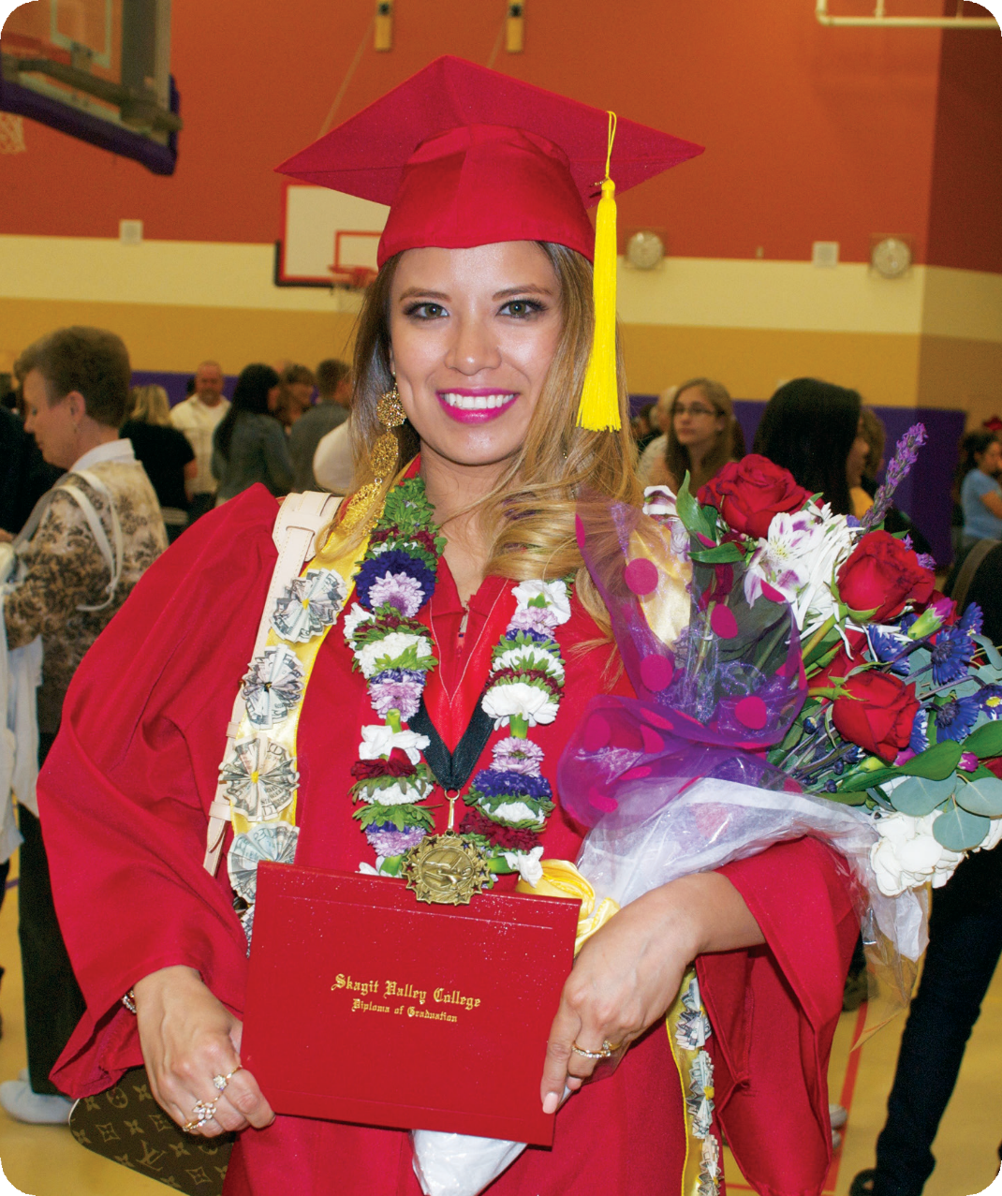

2015-2017 Operational Plan
2016 Mid-Cycle Update

Updated 06/2016

2015-17 Operational Plan

ACCESS
Develop and implement a comprehensive marketing plan for specific instructional programs, including:
  - Craft Brew
  - Criminal Justice
  - Fire
  - Manufacturing
  - Sustainable Agriculture
  - Technical Design
Seek grant funding for navigators to support undecided students, Spanish- speaking students needing financial aid assistance, Basic Skills students, and students in pre-college courses.
Acquire and implement CRM software to track student intake, recruitment, and academic progress.
Implement the next phase of the College Master Plan, including:
  - Preparation of a request for a major capital project in 2017-19
  - Improvements in District-wide Information Technology infrastructure
Expand the A-team.
**Implement Youth Re-Engagement program through BEdA and HS21+.
**Hire Director of High School Completion to oversee HS21+, Youth Re- Engagement, and traditional High School Completion.
**Implement Sedro Woolley High School ESL courses.
**Expand Spanish GED program.

Develop a plan for increased service to Basic Skills students at the Whidbey Island Campus and implement in 2016-2017.
Explore educational program opportunities for adults with intellectual disabilities.
  - **Implement new program 2016-2017
Continue lead and major gift phases of the Foundation’s Removing Barriers Campaign.

Assess the model of service delivery for the South Whidbey Center.
  - **Implement new model 2016-2017
Identify additional options for student housing.

Maximize financial aid funding for I-BEST students.

ACHIEVEMENT
Investigate a full-time faculty English position to implement Puente-inspired approaches to pre-college English, and to support the development of an Equity and Justice program.
Investigate hiring a full-time temporary faculty position to support Environmental Conservation, Geographic Information Systems, and Environmental Agriculture.
**Hire a full-time Nutrition faculty member to begin fall 2017.
**Hire a Chief Diversity and Equity Officer.
Hire an instructional designer for online classes.
**Hire a full-time position in Student Services to assist with enrollment and graduation processes.
**Identify military friendly pathways, including:

Increase credit for prior learning
Fee waiver

Assess staffing in eLearning.

**Implement Ex Libris ALMA in library and conduct LEAN analysis in preparation for the new system.
Implement an instructional dashboard.
**Automatically generate Canvas shells for all courses.
**Develop Evaluation Toolkit.
Implement District-wide student-driven and pathway-focused effective class scheduling.
Assess virtual mentors to support students in online courses with low retention rates.
**Create self-support position to coordinate dual credit programs
**Develop cohesive and comprehensive HS partnership plan
Purchase updated technology for the Computer Information Systems programs.
Implement a consistent, appropriate, District-wide model for student fees to support up-to-date instructional equipment and laboratory support.
**Review CIS and Marine Tech Fees.
Develop a comprehensive program to assure deep and diverse candidate pools, retention of diverse employees, and professional development opportunities for faculty and staff.
Establish a School of Business and International Studies.
Develop and implement a comprehensive student intake assessment for all students.
Investigate the development of an interdisciplinary Equity and Social Justice Department, and an Elder in Residence program.
Provide professional development opportunities for faculty on inclusive pedagogy.

Implement recommendations from the Advising Model Taskforce and the Student Services Policy Audit Taskforce, including:
  - Meaningful and appropriate pre-requisites for college-level classes
  - Support for undecided and developmental education students
  - Support for students filing for federal financial aid
  - Mandatory advising
  - First-year/quarter experience
  - Support for students who are not making satisfactory academic progress
  - Meaningful support for students attempting to enroll late
  - Guided pathways from basic education through degree completion
Reinforce commitment to learning communities and integrated assignments that foster student learning.

Implement program learning assessment and explore revision of General Education Learning Outcomes.

Assess continued use of Maxient to facilitate a consistent judicial process.

Implement a technology solution to integrate catalog information and the website.
Complete annual facilities maintenance projects, including:
  - Convert T-11 into P.E. space
  - Retain consultant to improve welding space utilization
Replace auto overhead doors
  - Hire a consultant to determine needed repairs in the Culinary Kitchen
  - Replace fire tower vent roof
Assess capacity of Athletics program.
**Research possible facilities changes required by Early Achievers standards for ECEAP.

**Investigate regular District-wide structured time-block for communication and collaboration.

COMMUNITY
Implement a tribal engagement plan based on needs expressed by tribal leadership.
Develop collaborative Latino cultural programs between Student Services, Instruction, and McIntyre Hall.
**Provide comprehensive (required) cultural competency training for all staff.
**Provide Safe Zone training and Train the Trainer program.
**Provide Title IX training for investigators/coordinator including trauma informed investigation skills.

LATINO COMMUNITY ENGAGEMENT
Finalize and implement plan to become a Hispanic-Serving Institution.
Better support undocumented students by:
- Providing professional development for faculty and staff
- Forming a taskforce to recommend policies and practices
- Identifying scholarships

GLOBAL CITIZENSHIP

**Assess staffing model in International Student Services and AESL and develop model for increased integration.
Establish the Skagit Global Environmental Institute.
Foster and deepen relationships with colleges and universities abroad, including:
  - Beijing Foreign Studies University, China
  - Instituto Tecnológico Superior de Puerto Vallarta, Mexico
  - AIB Polytechnic College, China
  - The University of Shiga Prefecture, Japan
  - Tenri University, Japan
  - Universidad Católica del Maule, Chile
  - Institute of Information Technology of Guilin University of Electronic Technology (GUET-IIT), China

ENVIRONMENTAL STEWARDSHIP

Host GlobalFest and the Sustainability Fair in alternating years.

UTILIZING 21ST CENTURY TECHNOLOGIES

Create and sustain an I.T. budget that addresses staffing, equipment and infrastructure needs.
**Hire a District-wide Web Content Manager.
Begin a District-wide office and classroom technology replacement plan.
Add I.T. staffing capacity to support online teaching and learning.

ALIGNING EDUCATIONAL PROGRAMS WITH REGIONAL AND STATE ECONOMIC DEVELOPMENT STRATEGIES

Develop and implement a Craft Beer Academy program.
**Launch additional cohort of Cardinal Craft Brew Academy program in a more traditional format.
**Develop a plan for improved Fire Science, Diesel and Manufacturing facilities.
**Continue current apprentice contracts.
**Continue AJAC Manufacturing Academy.
**Investigate adding BAS program in Applied Management.

INSTITUTIONAL CAPACITY/SUPPORT
Develop a comprehensive plan to implement ctcLink across the District.
**Hire ctcLink Project Manager beginning 1/1/17.
**Investigate hiring of full-time Director of Security and Emergency Management.

**Offer First Aid/CPR (&AED) training to all permanent part-time and full-time employees in all job classifications.
**Add District policy, planning and training responsibilities to Directors of IT, Security, and Facilities.
**Investigate increased Security presence during operating hours at Whidbey Island Campus.
**Research replacement of Old Main Roof on Whidbey Island Campus.
**Research deck replacement at Hayes Hall at Whidbey Island Campus.
**Research relocation of San Juan Center Radio Tower.
**Investigate increased integration of McIntyre Hall, Culinary Arts and College Advancement efforts.
**New item in 2016-2017

